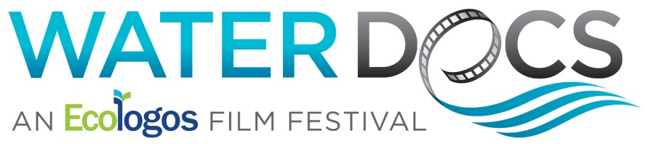
Sixth Annual Water Docs Film Festival Kicks Off with Toronto Premiere of The Peel Project, March 30

Water Docs celebrates five days of hydro-dynamic, water-themed documentary films, Wednesday, March 29 through Sunday, April 2 at Toronto’s Hot Docs Ted Rogers Cinema

Festival punctuates opening night film The Peel Project with live musical performance before the screening and after party featuring original art created by artists from the documentary, Thursday, March 30

Water Docs explores how the iconic blue jean is killing the world’s rivers in pre-opening night, Toronto premiere of RiverBlue at University of Toronto’s OISE Auditorium, Wednesday, March 29

To tweet this release:

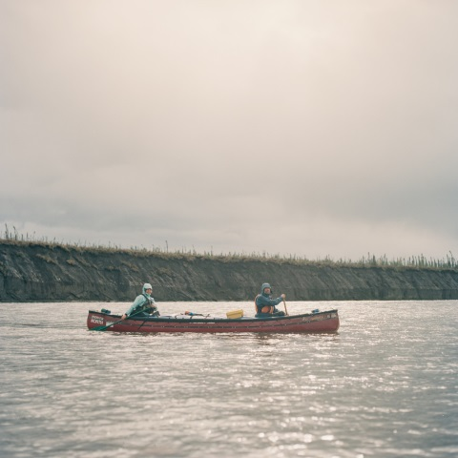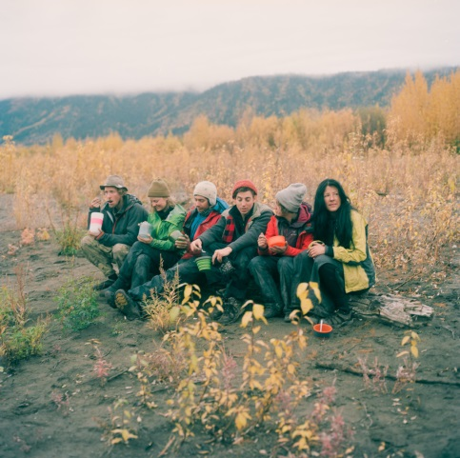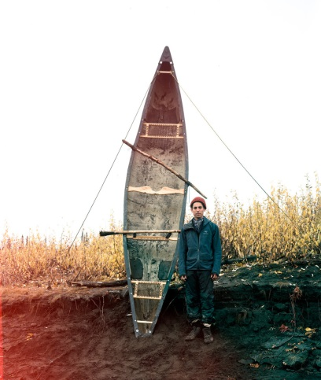
Stills from The Peel Project (left to right): Paddlers journey up the Peel watershed; group of artists on journey; co-director Anthony Wallace with wind harp creation.

TORONTO (March 1, 2017) – Kicking off Wednesday, March 29, an irresistible wave of water-themed documentaries washes over Toronto with the sixth annual Water Docs Film Festival, turning the lens on issues facing local and global water systems, and celebrating water’s magical, mystical, life-giving properties. With a lineup of six feature film screenings and more than a dozen shorts over its five-day course (March 29 – April 2), Water Docs officially opens on Thursday, March 30 with the Toronto premiere of The Peel Project, a story of art, adventure, and the Canadian wilderness as documented in a cinematic journey across the Peel River Watershed, one of the last intact river systems left in North America. Directed by Calder Cheverie and Anthony Wallace, The Peel Project is an exploration of Canadian identity that examines whether Canada’s last pristine watershed can be saved from development. The opening screening takes place at Hot Docs Ted Rogers Cinema (506 Bloor St. W.).

The opening night screening will be followed by Water Docs’ official opening night reception “Dancing with Water” taking place Thursday, March 30 on the main floor of the Centre for Social Innovation (CSI) Annex (720 Bathurst St.), and is open to all screening attendees. The event celebrates all things water and Water Docs 2017 with an installation of the resulting artistic visions of The Peel Project’s participating artists. Photography, paintings, sculptures and soundscapes will be on display throughout the evening and over the course of the following week until Friday, April 7 at CSI Annex. Attendees are invited to view the Canadian premiere of the beautiful, short, meditative film River, also screening during the reception.

Throughout the five-day festival, Water Docs overflows with screenings and events, along with Q&A and panel discussions with filmmakers and experts from the water community. A complete list of festival programming with descriptions and links to trailers is available online at http://www.waterdocs.ca/2017/.

“Water Docs’ mission is to make waves with audiences by inspiring filmgoers to reconnect with the power of water which ripples deeply within us all, and awakening action to protect the earth’s most powerful resource – without which nothing could live,” said Stan Gibson, Founder and Executive Director, Ecologos and the Water Docs Film Festival. “This year’s amazing film lineup features stunning cinematography while highlighting some of the growing crises that threaten precious water sources across the globe. We’re honoured to provide a platform that magnifies the issues facing the world’s finite fresh water supply, and to unite, educate, and motivate audiences to take action.”

Ticket information is available online at http://waterdocs.bpt.me/
Festival passes are only $20 and will admit attendees to all screenings.
General Adult Admission: $10
Underwaged: Pay what you can, minimum $5

The following is a listing of the Water Docs Film Festival slate of feature documentary programming:

Wednesday, March 29 at 6 p.m. – Pre-Festival Special Screening Event:
“Fashion’s Deep Water Impacts” – OISE Auditorium, 252 Bloor Street West. **Filmmaker Q&A and panel discussion to follow screening.

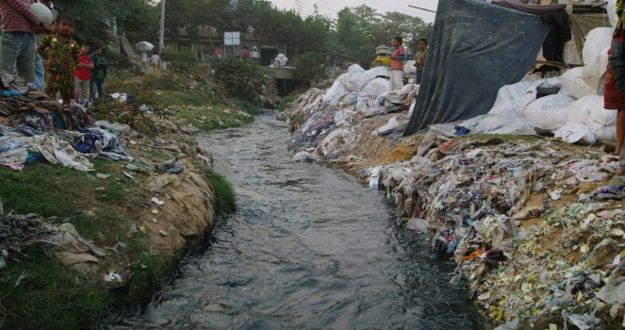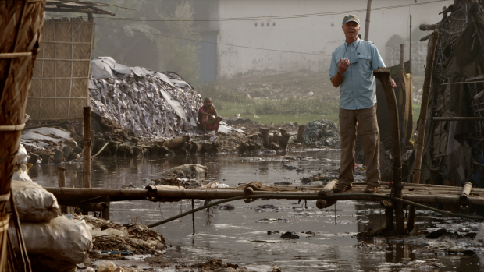
Stills from RiverBlue (left to right): River in India; Mark Angelo, river conservationist and key subject of documentary.

Feature: RiverBlue – Toronto premiere presented by Water Docs in association with the U of T Student Chapter of the Ontario Water Works Association (OWWA) **FREE OF CHARGE and OPEN TO THE PUBLIC

Description: Narrated by Jason Priestley, RiverBlue journeys through some of the world's most pristine waterways to some of its most polluted, in an unprecedented global adventure that reveals the dark side of the fashion industry. The film uncovers how harsh chemical manufacturing processes and irresponsible disposal of toxic waste is destroying the world’s rivers.
Trailer: https://youtu.be/pfPMeMGbrj4

Thursday, March 30 at 6:30 p.m. – Water Docs Opening Night: “Water Inspires Art” — Hot Docs Ted Rogers Cinema, 506 Bloor Street West. ** Filmmaker Q&A and discussion to follow screening

Feature: The Peel Project – Toronto premiere (feature)
Description: Six artists paddle into the Arctic - A story of Art, Adventure and Canadian Wilderness. In jeopardy of development, The Peel Project highlights the landscape, culture and wildlife of the Peel River Watershed, one of the last intact river systems left in North America.
Trailer: https://youtu.be/xNJPnbwuOhc

Shorts: Xelaltxw
Downstream
Mining the Mother Lode

Friday, March 31 at 6 p.m. – Ontario150 Film Challenge Awards Night: “Water’s Rising Tides of Change” — Hot Docs Ted Rogers Cinema, 506 Bloor Street West. ** Filmmaker Q&A and discussion to follow screening

Feature: Sea of Life
Shorts: In Season
Conserving Water in Urban Areas

Sea of Life follows filmmaker Julia Barnes on an underwater adventure to discover the truth about the biggest threats facing the ocean and ultimately ourselves.
Trailer: https://youtu.be/64JdlumDRik

Saturday, April 1 – Water Docs Saturday Matinée: “The Joy of Water” — Hot Docs Ted Rogers Cinema, 506 Bloor Street West. ** Filmmaker Q&A and discussion to follow screening

Feature: Standing on Water
Shorts: Snowglobe
Hand.Line.Cod.

A story of overcoming your fears and following your passion, Standing on Water is the journey of how Casper Steinfath, despite his fear of water, became one of the best stand-up paddle surfers in the world and the only paddle surfer from Denmark.
Trailer: https://youtu.be/GD3tQE3w7Vo

Saturday, April 1 – Water Docs Saturday Night: “Traditional Water Wisdom” — Hot Docs Ted Rogers Cinema, 506 Bloor Street West. ** Filmmaker Q&A and discussion to follow screening.

Feature: Putuparri and the Rainmakers
Short: The Rainmakers of Nganyi

Researchers at Kenyan universities start to use rainmakers in the village of Nganyi, Western Kenya, as communication agents in an attempt to convince people to listen to their forecasts. But then they started to notice striking similarities between their predictions and those of the rainmakers.
Trailer: https://youtu.be/9m9gejLuR8w

Sunday, April 2 – “Water Drops Shorts Program” — Hot Docs Ted Rogers Cinema, 506 Bloor Street West. ** Filmmaker Q&A and discussion to follow screening.

Shorts Program:
Skeleton Sea: The Tides of Tomorrow (Canadian Premiere)
Conserving Water in Urban Areas (World Premiere)
The Diver
En la Orilla (At the Edge)
The Storm Downstream (Canadian Premiere)
The Canoe

About Water Docs Film Festival
Dedicated to presenting independent, ground-breaking, water-themed documentaries, Water Docs Film Festival is an annual exhibition that celebrates and promotes water protection and conservation. Water Docs provides a platform for vital discussions, and serves as a catalyst for change by providing opportunities to take action. Now in its sixth year, the festival delivers four diverse learning and action programs developed under the Water Docs Film Festival banner, including the innovative Water Docs @ School Action Projects, currently rolled out in dozens of Grade 8 classes across Ontario. Water Docs Film Festival is produced by Ecologos and co-presented with Toronto and Region Conservation. Ecologos is a charitable, volunteer-driven organization that engages thousands of people each year in programs that celebrate a sense of reverence for water, inform about the challenges that threaten clean water supplies, and inspire action in defence of nature’s most precious resource.

– H₂0 –
For more information, contact:
Patricia Garcia, Water Docs Publicity -- 416.302.9318 or waterdocsinfo@gmail.com

